If the server is a third party company, you might have a service-level agreement stating: "Our API will always respond in 150ms". Great, set it to 150ms (and retry on failure if the thing is important.)
If the service is in-house, then try to get access to NewRelic, CA APM or whatever monitoring tool is being used. Looking at the response times, you can get an idea of what should be acceptable. Be careful though, do not look only at the average.
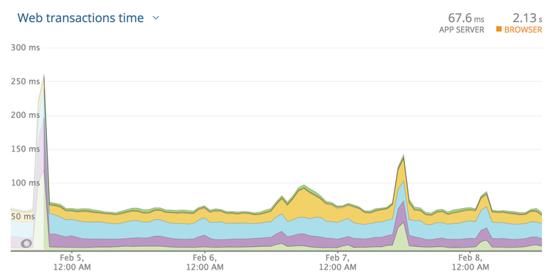
Looking at this graph may lead you to think 300ms is an appropriate timeout. Seems fair right? The biggest spike there is 250ms and so round it up a bit and let's go for 300ms?
Nope! These are averages, and averages are going to be far far lower than the slowest transactions. Click the drop-down and find "Web transaction percentiles."
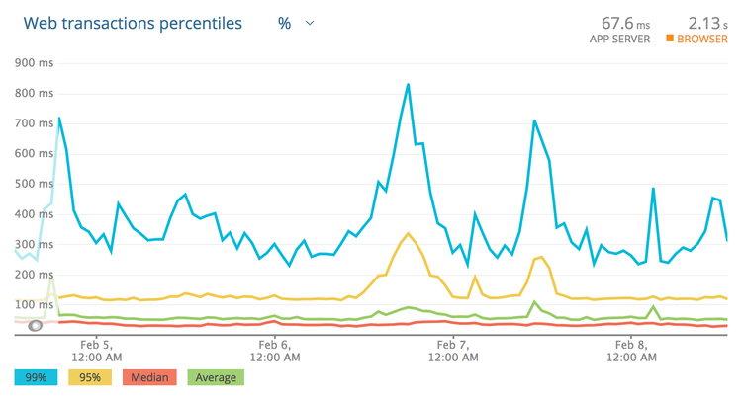
That is a more honest representation. Most of the responses are 30-50ms, and the average is usually sub 100ms. That said, under high load this service starts to stutter, and these peaks can lead to responses coming in around 850ms! Clicking around to show the slowest traces will show a handful of requests over the last few weeks coming in at 2s, 3.4s, and another at 5s!
Those are ridiculous, and looking at the error rate we can see that those requests didn't even succeed. Whatever happens, setting the timeout low enough to cut those off is something we want to do, so far I'm thinking about 1s. If the transactions are failing anyway, there is no point waiting.
Next: if the call is being made from a background worker, that 99 percentile of 850ms may well be acceptable. Background workers are usually in less of a rush, so go with 1s and off you go. Keep an eye on things and trim that down if your jobs continue to back up, but that's probably good enough.

